EXPERIMENT 10

Write a C program to print the addresses of a variable and enter a long loop

1. Start three to four processes of the same program and observe the printed addressed values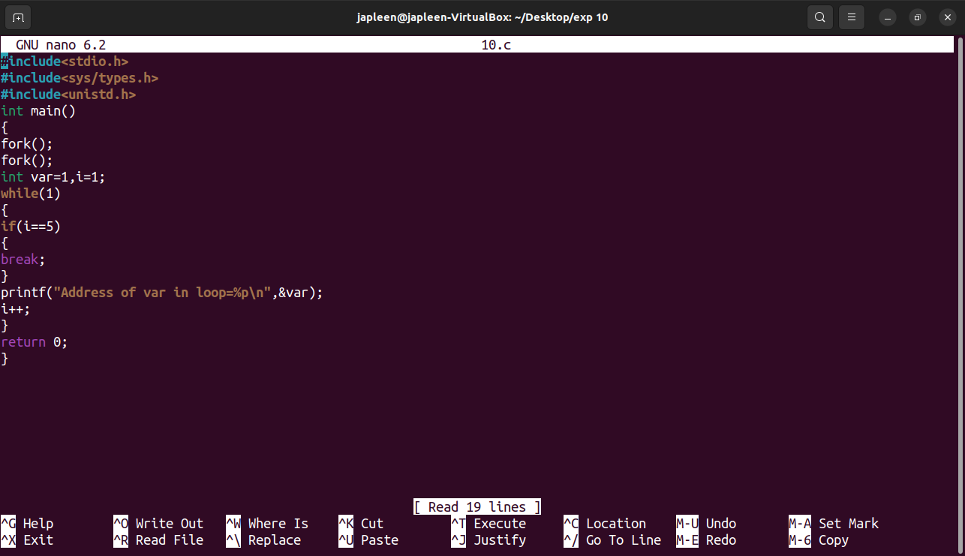

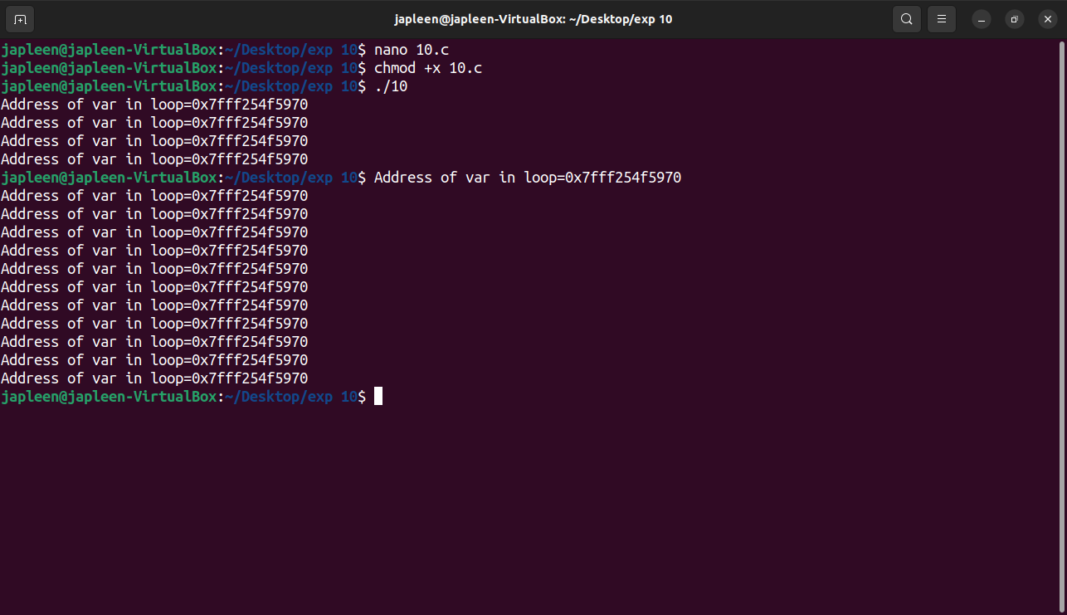

1. Show how two processes which are members of the relationship parent child are concurrent from execution point of view , initially the child is copy of the parent,but every process has its own data